UNITED ASSOCIATION
OF

STEAMFITTERS-PIPEFITTERS-SERVICE TECHNICIANS
Local Union No. 455

1301 L ORIENT STREET ST. PAUL, MN 55117 (651) 455-0455
(651)647-1566 Fax

310 McKINZIE ST.
MANKATO, MN 56001
(507) 625-5126
(507)625-5014 Fax
AFL - CIO

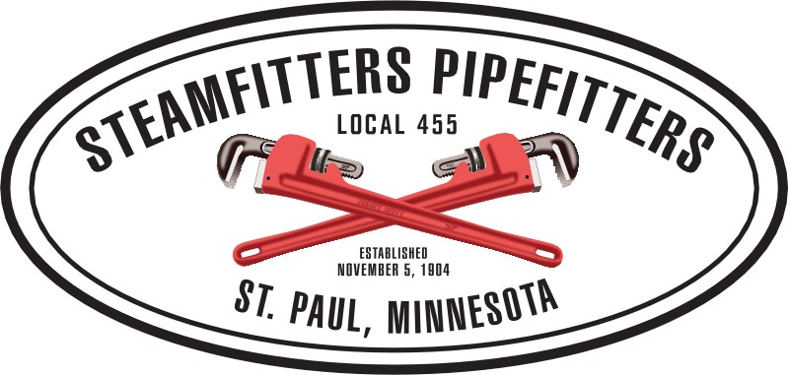
TONY POOLE
Business Manager
SCOTT SEATH
Financial Secretary Treasurer
RYAN HOEN
Business Representative
JIM SLOAN
Business Representative
GINO LOWE
Business Representative Zone II

An Important Reminder

Members need to stay home if you are not working. If you are working insist on an N95 3M mask from your contractor, most should already have them. Additionally, always wear gloves, demand hand washing stations, and maintain 6 ft of distance from others at all times, including while at break. Lastly, if you feel ANY symptoms, STAY HOME.
The local will do everything we can to help you and your family if you require assistance.

Thank you,

_____________________________
Tony Poole
Business Manager

Affiliated with the United Association of Journeymen and Apprentices of the Plumbing and Pipe fitting Industry of the United States and Canada, AFL-CIO

